



PRODUCT SPECIFICATION
PRODUCT SPECIFICATION

Preliminary

P/N：PO-MT3535CWSN-A01

CUSTOMER  APPROVED  SIGNATURES | APPROVED BY | CHECKED BY | PREPARED BY

- Features

- Small package with high efficiency
- RoHs Compliant and Pb-Free
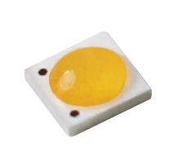
- Energy Star / ANSI compliant binning structure

- Application
- Tiny illumination
- PAR 30 light bulb
- Spot light
- Indicator

- Absolute Maximum Ratings

（Ta=25℃）
Parameter | Symbol | Rating | Unit
Max Pulse Power Dissipation | P_{D} | 3 | W
Forward Current (DC) | I_{F} | 700 | mA
Forward Voltage (DC) | V_{F} | 3.6 | V
Reverse Current | I_{R} | 85 | mA
Operating Temperature | Topr | -40 ~ +100 | ℃
Storage Temperature | Tstg | -40 ~ +100 | ℃
LED junction temperature | Tj | 120 | ℃

- Mechanical Dimension

Cathode Mark
Cathode Mark

(unit:mm)

Note:
- Dimensions are in millimeters.
- Tolerance +/- 0.2 mm.

- Luminous Flux Characteristics
（Ta=25℃）
Color | CCT | Part No. | CRI | Luminous Flux (lm) |  |  | Condition
Color | CCT | Part No. | Ra | Min | Type | Max | Condition
Cool White | 5700K | PO-MT3535CWSN-A01 | 70 | 90 | / | 140 | IF=350mA
Note:
- Maintains a tolerance of ±10% on Luminous Flux measurements.
- Maintains a tolerance of ±2% on CRI measurements.
- Optical Characteristics
（Ta=25℃）
Color | Part No. | Color Temperature |  |  | Typical  View Angle  (Degrees)  2θ ½
Color | Part No. | Min. | Typ. | Max. | Typical  View Angle  (Degrees)  2θ ½
Cool White | PO-MT3535CWSN-A01 | 4745 | / | 7040 | 120∘
Note:
- Maintains a tolerances of ±5% for CCT measurements.
- Electrical Characteristics
Ta=25℃）
Color | Part No. | Forward Voltage VF(V) |  |  | Condition
Color | Part No. | Min | Type | Max | Condition
Cool White | PO-MT3535CWSN-A01 | 2.9 | / | 3.6 | IF=350mA
Note:
1. Maintains a tolerance of ±1v on Forward Voltage measurements.

- Bin Range Of Luminous Intensity

Bin | Min | Max | Unit | Condition
AB | 90 | 100 | lm | IF=350mA
AC | 100 | 110 | lm | IF=350mA
AD | 110 | 120 | lm | IF=350mA
AE | 120 | 130 | lm | IF=350mA
AF | 130 | 140 | lm | IF=350mA

- Bin Range Of Forward Voltage

Bin | Min | Max | Unit | Condition
H1 | 2.9 | 3.0 | V | IF=350mA
H2 | 3.0 | 3.1 | V | IF=350mA
I1 | 3.1 | 3.2 | V | IF=350mA
I2 | 3.2 | 3.3 | V | IF=350mA
J1 | 3.3 | 3.4 | V | IF=350mA
J2 | 3.4 | 3.5 | V | IF=350mA
K2 | 3.5 | 3.6 | V | IF=350mA

- Typical Electro-Optical-Thermal Characteristics Curves

(T_{A}=25℃ Unless Otherwise Noted)
1.Relative Luminous Flux vs. Forward Current | 2.Forward Voltage vs. Forward Current
3.Relative Luminous Flux vs. Ambient Temperature | 4.Forward Voltage vs. Ambient Temperature
5.Spectrum Distribution-CRI 70 | 6. Radiation Diagram

- ANSI Chromaticity Bin Table
Cool White BIN Structure 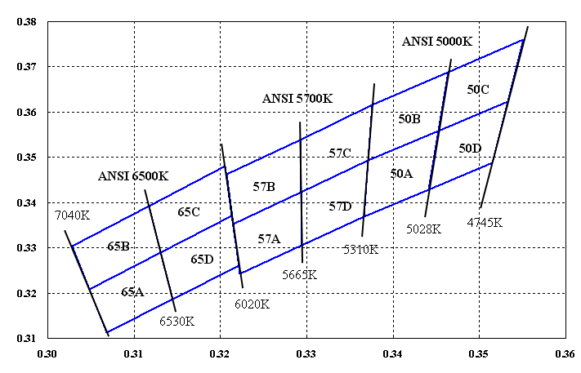
Note :The red dashed circle is main bin

Bin code | CIE-x | CIE-y |  | Bin code | CIE-x | CIE-y |  | Bin code | CIE-x | CIE-y
65A | 0.3068 | 0.3113 |  | 57A | 0.3222 | 0.3243 |  | 50A | 0.3371 | 0.3493
65A | 0.3145 | 0.3187 |  | 57A | 0.3294 | 0.3306 |  | 50A | 0.3452 | 0.3558
65A | 0.3131 | 0.3290 |  | 57A | 0.3293 | 0.3423 |  | 50A | 0.3441 | 0.3428
65A | 0.3048 | 0.3209 |  | 57A | 0.3215 | 0.3353 |  | 50A | 0.3366 | 0.3369
65B | 0.3048 | 0.3209 |  | 57B | 0.3215 | 0.3353 |  | 50B | 0.3376 | 0.3616
65B | 0.3131 | 0.3290 |  | 57B | 0.3293 | 0.3423 |  | 50B | 0.3464 | 0.3688
65B | 0.3117 | 0.3393 |  | 57B | 0.3292 | 0.3539 |  | 50B | 0.3452 | 0.3558
65B | 0.3028 | 0.3304 |  | 57B | 0.3207 | 0.3462 |  | 50B | 0.3371 | 0.3493
65C | 0.3131 | 0.3290 |  | 57C | 0.3292 | 0.3539 |  | 50C | 0.3464 | 0.3688
65C | 0.3213 | 0.3371 |  | 57C | 0.3293 | 0.3423 |  | 50C | 0.3551 | 0.3760
65C | 0.3205 | 0.3481 |  | 57C | 0.3371 | 0.3493 |  | 50C | 0.3533 | 0.3624
65C | 0.3117 | 0.3393 |  | 57C | 0.3376 | 0.3616 |  | 50C | 0.3452 | 0.3558
65D | 0.3145 | 0.3187 |  | 57D | 0.3294 | 0.3306 |  | 50D | 0.3452 | 0.3558
65D | 0.3221 | 0.3261 |  | 57D | 0.3366 | 0.3369 |  | 50D | 0.3533 | 0.3624
65D | 0.3213 | 0.3371 |  | 57D | 0.3371 | 0.3493 |  | 50D | 0.3515 | 0.3487
65D | 0.3131 | 0.3290 |  | 57D | 0.3293 | 0.3423 |  | 50D | 0.3441 | 0.3428
Note:
Maintains a tolerances of ±0.01 on Color coordinates measurements.

- PACKAGING
PO-MT3535CWSN-A01 High Power LEDs are packaged in reel of 1000 paces and placed inside a carton.
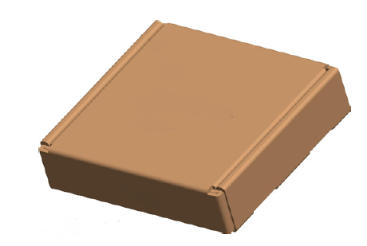
LABEL
BIN CODE
Lot
Qty
LABEL
BIN CODE
Lot
Qty
Carton
CARTON

