



PRODUCT SPECIFICATION
PRODUCT SPECIFICATION

Preliminary

P/N：PO-MT3535NWSN-D01

CUSTOMER  APPROVED  SIGNATURES | APPROVED BY | CHECKED BY | PREPARED BY

- Features

- Small package with high efficiency
- RoHs Compliant and Pb-Free
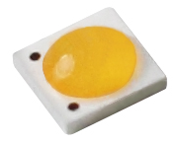
- Energy Star / ANSI compliant binning structure

- Application
- Tiny illumination
- PAR 30 light bulb
- Spot light
- Indicator

- Absolute Maximum Ratings

（Ta=25℃）
Parameter | Symbol | Rating | Unit
Max Pulse Power Dissipation | P_{D} | 3 | W
Forward Current (DC) | I_{F} | 700 | mA
Forward Voltage (DC) | V_{F} | 3.6 | V
Reverse Current | I_{R} | 85 | mA
Operating Temperature | Topr | -40 ~ +100 | ℃
Storage Temperature | Tstg | -40 ~ +100 | ℃
LED junction temperature | Tj | 120 | ℃

- Mechanical Dimension

Cathode Mark
Cathode Mark

(unit:mm)

Note:
- Dimensions are in millimeters.
- Tolerance +/- 0.2 mm.

- Luminous Flux Characteristics
（Ta=25℃）
Color | CCT | Part No. | CRI | Luminous Flux (lm) |  |  | Condition
Color | CCT | Part No. | Ra | Min | Type | Max | Condition
Natural White | 4000K | PO-MT3535NWSN-D01 | 80 | 90 | / | 140 | IF=350mA
Note:
- Maintains a tolerance of ±10% on Luminous Flux measurements.
- Maintains a tolerance of ±2% on CRI measurements.
- Optical Characteristics
（Ta=25℃）
Color | Part No. | Color Temperature |  |  | Typical  View Angle  (Degrees)  2θ ½
Color | Part No. | Min. | Typ. | Max. | Typical  View Angle  (Degrees)  2θ ½
Natural White | PO-MT3535NW-D01 | 3710 | / | 4745 | 120∘
Note:
- Maintains a tolerances of ±5% for CCT measurements.
- Electrical Characteristics
Ta=25℃）
Color | Part No. | Forward Voltage VF(V) |  |  | Condition
Color | Part No. | Min | Type | Max | Condition
Natural White | PO-MT3535NW-D01 | 2.9 | / | 3.6 | IF=350mA
Note:
1. Maintains a tolerance of ±1v on Forward Voltage measurements.

- Bin Range Of Luminous Intensity

Bin | Min | Max | Unit | Condition
AB | 90 | 100 | lm | IF=350mA
AC | 100 | 110 | lm | IF=350mA
AD | 110 | 120 | lm | IF=350mA
AE | 120 | 130 | lm | IF=350mA
AF | 130 | 140 | lm | IF=350mA

- Bin Range Of Forward Voltage

Bin | Min | Max | Unit | Condition
H1 | 2.9 | 3.0 | V | IF=350mA
H2 | 3.0 | 3.1 | V | IF=350mA
I1 | 3.1 | 3.2 | V | IF=350mA
I2 | 3.2 | 3.3 | V | IF=350mA
J1 | 3.3 | 3.4 | V | IF=350mA
J2 | 3.4 | 3.5 | V | IF=350mA
K2 | 3.5 | 3.6 | V | IF=350mA

- Typical Electro-Optical-Thermal Characteristics Curves

(T_{A}=25℃ Unless Otherwise Noted)
1.Relative Luminous Flux vs. Forward Current | 2.Forward Voltage vs. Forward Current
3.Relative Luminous Flux vs. Ambient Temperature | 4.Forward Voltage vs. Ambient Temperature
5.Spectrum Distribution-CRI 80 | 6. Radiation Diagram

- ANSI Chromaticity Bin Table
Natural White BIN Structure 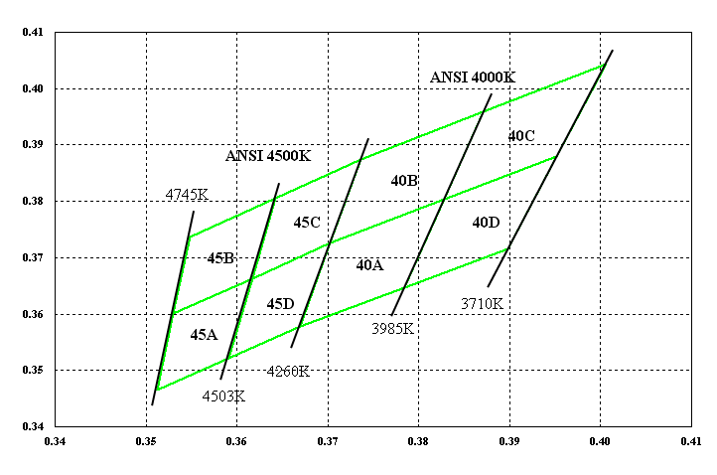
Note :The red dashed circle is main bin

Bin code | CIE-x | CIE-y |  | Bin code | CIE-x | CIE-y
45A | 0.3152 | 0.3465 |  | 40A | 0.3670 | 0.3578
45A | 0.3530 | 0.3601 |  | 40A | 0.3703 | 0.3726
45A | 0.3617 | 0.3663 |  | 40A | 0.3828 | 0.3803
45A | 0.3591 | 0.3522 |  | 40A | 0.3784 | 0.3647
45B | 0.3530 | 0.3601 |  | 40B | 0.3703 | 0.3726
45B | 0.3548 | 0.3736 |  | 40B | 0.3736 | 0.3874
45B | 0.3642 | 0.3805 |  | 40B | 0.3871 | 0.3959
45B | 0.3617 | 0.3663 |  | 40B | 0.3828 | 0.3803
45C | 0.3617 | 0.3663 |  | 40C | 0.3828 | 0.3803
45C | 0.3642 | 0.3805 |  | 40C | 0.3871 | 0.3959
45C | 0.3736 | 0.3874 |  | 40C | 0.4006 | 0.4044
45C | 0.3703 | 0.3726 |  | 40C | 0.3952 | 0.3880
45D | 0.3591 | 0.3522 |  | 40D | 0.3784 | 0.3647
45D | 0.3617 | 0.3663 |  | 40D | 0.3828 | 0.3803
45D | 0.3703 | 0.3726 |  | 40D | 0.3952 | 0.3880
45D | 0.3670 | 0.3578 |  | 40D | 0.3898 | 0.3716
Note:
Maintains a tolerances of ±0.01 on Color coordinates measurements.

- PACKAGING
PO-MT3535NWSN-D01 High Power LEDs are packaged in reel of 1000 paces and placed inside a carton.
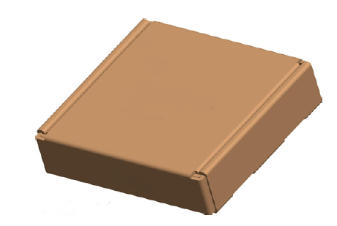
LABEL
BIN CODE
Lot
Qty
LABEL
BIN CODE
Lot
Qty
Carton
CARTON

